No Point (Floating) Star Block in Patriotic Colors
April 2024 Block Party
Block Size: 12.5 inches X 12.5 inches unfinished, 12x12 finished inside a quilt.
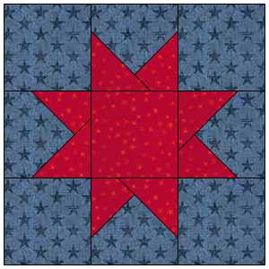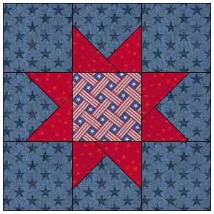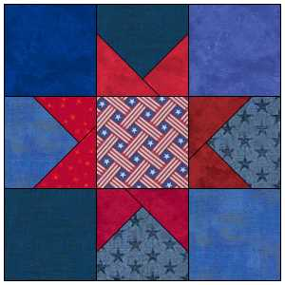

It has come to our attention that we have had requests for Veteran/red, white and blue quilts from our service committee (charity quilts), but we don’t have any right now. So we decided to use this Block Party to help fill the gap.
This block is basically a nine-patch star. It is called “floating” or “no points” because the star itself is more than ¼ inch from the edge of the fabrics therefore there is more forgiveness with the points of the star. Also, the two points sharing the same side are created by overlapping triangles, so you don’t have to line up their points with the side of the center box, adding to the forgiveness.
The main techniques used are ¼ inch seams and “folded clipped corners”.
Fabric Requirements:
If using Fat Quarters, you can make 2 squares from 2 fat quarters. Just use the 4.5” squares from one fat quarter and the 3.5” squares from the other to make a block.

If using yardage, you need
- one 4.5” strip for the background (if the usable fabric is at least 40.5”, you can also get the center square from this strip)
- one 3.5” strip for the Star points
- one 4.5” square for the center square
CUTTING:
In total, we will need 9 – 4.5 “ blocks and 8-3.5” blocks, as follows
Color 1 – Background 8 – 4 ½” squares
[55060 (Go Die) ]
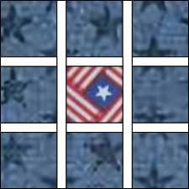
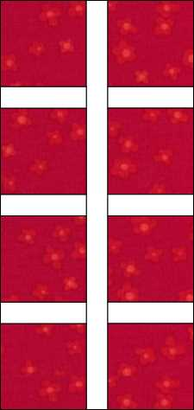
Can be a scrappy collection of similar colors, if necessary

Color 2 – Star Color
8 – 3 ½” squares
[55006 (Go Die)]
Can be scrappy pairs of squares of similar colors, if necessary.

Color 3 – Center of star
1 – 4 ½’ square
[55060 (Go Die) ]
Can match the Main Color, or maybe be a patriotic fabric.

DIRECTIONS:
- First create the star points using a folded corner method. Some people also call this “stitch and flip”. I will show you a method that does not require any special tools.
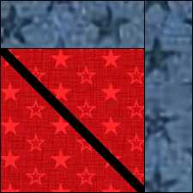
  - Grab one of the background 4.5 inch squares and two of the 3.5 inch squares.
  - Mark a diagonal line across the backs of the small squares with a pencil or other marking tool, from corner to corner in one direction.
  - Lay a smaller square on the larger square RIGHT SIDES TOGETHER, lining the smaller square up in a corner of the larger square with the diagonal lines running across each corner.
  - Stitch on the marked line.
  - Cut ¼ inch from the stitched line, toward the corner. 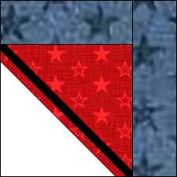
  - Press the seam open, or toward one side. 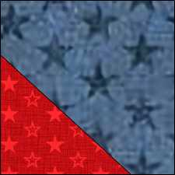
  - Lay the second square on the block, with an empty corner in one of the corners next to the one you just completed, again with the diagonal line running from edge to edge.
  - Stitch on the marked line.
  - Trim the seam to ¼ inch from the stitched line, toward the corner.
  - Press the seam open or to the side, similar to what you did for the other side.
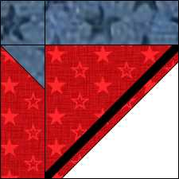
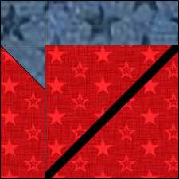
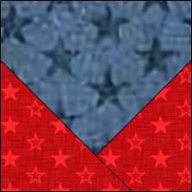

  - Trim the square back to 4.5” x 4.5” if necessary.

- Layout the blocks for the final square.
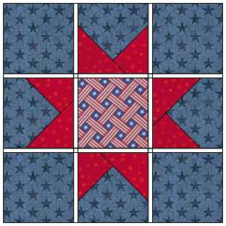

- Seam across the rows with ¼ inch seams and press the seams in the direction shown in the diagram. (Top and bottom rows to the outside, middle row to the center)
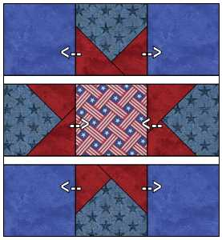
- Seam the rows together with ¼ inch seams, nesting row seams, and press the seams toward the center of the block as shown in the diagram. (toward the center of the block)
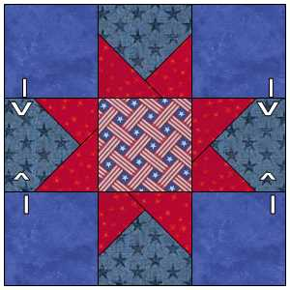
- Congratulations! Your finished creation should measure 12.5” x 12.5”

Appendix A – Some possible options and tools for Folded Corner Clipping/”stitch and flip”
These directions show a simple way to do “folded corners”, but here are some other techniques you may see people use.
- Creative Grids® Folded Corner Clipper – CGRFCC – YouTube Video
https://www.youtube.com/watch?v=cpSZ6lqvc34
- Cluck Cluck Sew Tape method with Painters Tape
http://cluckclucksew.com/2010/10/triangle-corner-trick.html
- Cluck Cluck Sew method with their diagonal Seam Tape.
https://cluckclucksew.com/diagonalseamtape

